**Nutil: Neuroscience Image Processing and Analysis Utilities**

**USER MANUAL**

*Nutil* is a pre- and post-processing toolbox for 2D microscopic images, with three main functions:

1. ***TiffCreator*:** for the production of tiled TIFF files from JPEG/PNG images.
2. ***Transform:*** for the batch renaming, rotation, resizing and thumbnail compilation of large tiled TIFF images.
3. ***Quantifier***: for the batch extraction, quantification and spatial analysis of segmented labelling (immunohistochemical or otherwise) in 2D rodent brain section image series.

***Quantifier*** relies on input from segmentations and customised atlas maps derived from the brain section images. The tool outputs are quantification of objects per atlas region, custom atlas maps with superimposed colour-coded features, and coordinates for visualisation in 3D reference atlas space.

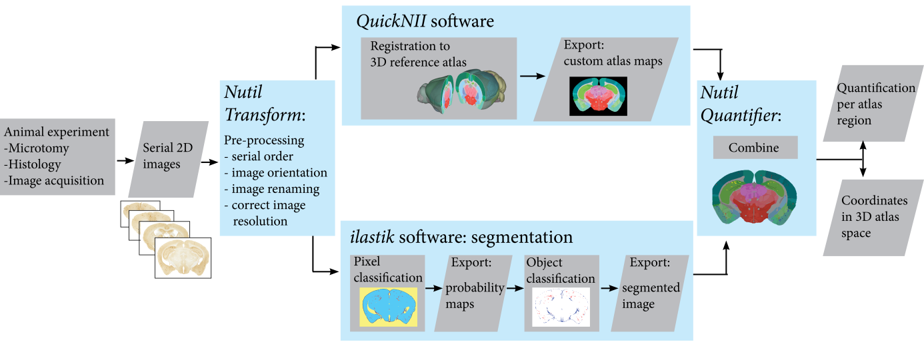

**Figure 1** Analytical Workflow developed by the Nesys laboratory for the quantification and spatial analyse of microscopic rodent brain section labelling using Nutil.

**INSTALLATION AND USAGE**

* *Nutil* is a stand-alone 64-bit windows application that can be downloaded at <https://www.nitrc.org/projects/nutil/>
* There are no installation procedures, just extract the folder and double click on "Nutil.cmd".
* *Nutil* contains a self-updater. New versions do not have to be manually downloaded.
* The *Nutil* package contains an Excel template with separate sheets for ***TiffCreator***, ***Transform*** and ***Quantifier.***

1. **Operation:** ***TiffCreator***

The ***TiffCreator*** function can be used to create tiled TIFF images from JPEG, PNG, BMP and GIF images (the Transform function will only work on tiled TIFFs). The function operates in batch, converting all the images in a selected input directory and saving them in the specified output directory.

1. To begin, save a new copy of the *Excel template*, and populate the purple fields in the ***TiffCreator*** sheet with the input directory, output directory, output compression, and tile size.

NOTE: See the green fields and pop-up boxes for instructions.

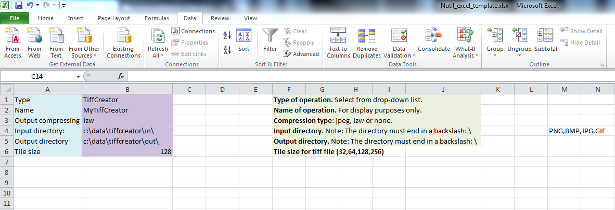

1. Start the *Nutil* software by double-clicking on the "Nutil.cmd" file in the *Nutil* directory. On opening, you are presented with a simple screen:

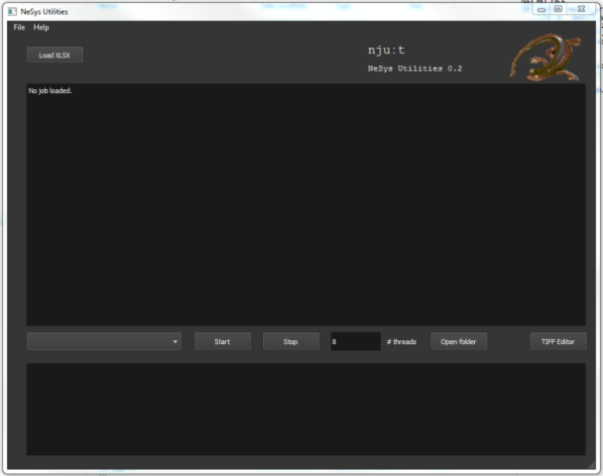

1. Click the “Load XLSX”-button and navigate to the *Excel template*.
2. Select ***TiffCreator*** from the lower drop-down box. *Nutil* automatically detects the number of core processor available (8 in this example). Choose a number below the total available (6 or 7).
3. Press "Start" and wait until the batch process is complete. The tiled TIFFs are automatically saved to the output directoryspecified in the *Nutil* Excel template.
4. **Operation:** ***Transform***

The ***Transform*** function allows batch renaming, rotation, resizing and thumbnail compilation of large tiled TIFF images.

1. Save a copy of the *Excel template*, and populate the purple fields in the ***Transform*** sheet with the location of the input and output directories, and specifications such as output compression, thumbnail size and file type, background colour, etc.

NOTE: See the green fields and pop-up boxes for further instructions.

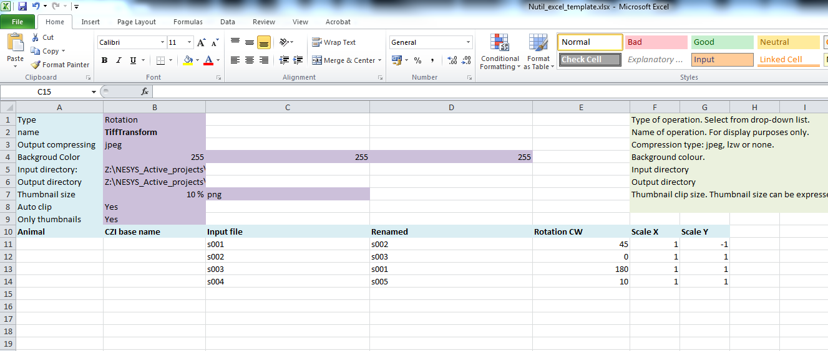

1. List the names of the image files that you wish to transform in the *input file* column with the transformation parameters (angle to rotate, resizing scale along the x and y axis, etc).

NOTE! Don’t leave an empty row in the upper part, start directly at row 11.

1. Start the *Nutil* software by double-clicking on the "Nutil.cmd" file in the *Nutil* directory. On opening, you are presented with a simple screen:

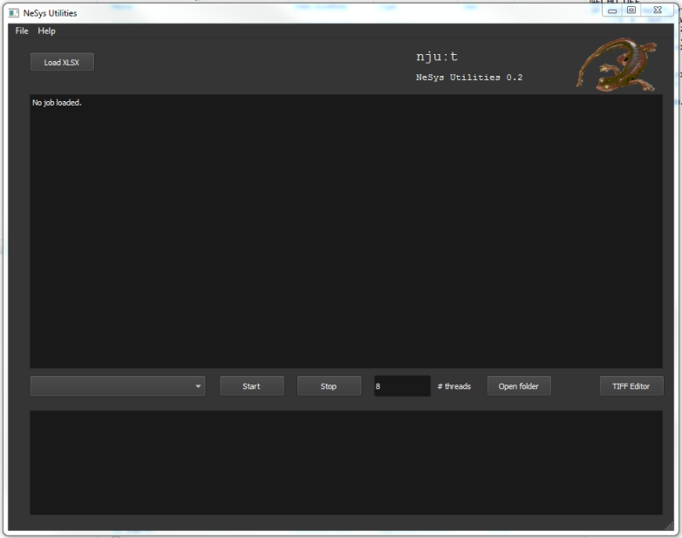

1. Click the “Load XLSX”-button and navigate to the populated *Nutil Excel template*.
2. Select ***Transform*** from the lower drop-down box. *Nutil* automatically detects the number of available processors (8 in the example). Choose a number below the total number available (e.g. 6 or 7).
3. Press "Start" and wait until the batch process is complete. The output files are automatically saved to the output directoryspecified in the *Nutil* excel template.

NOTE: Depending on the original size of the images, this may take some time. Be patient, and leave overnight if necessary.

1. **Operation:** ***Quantifier***

***Quantifier*** is a batch post-processing operation that relies on input from 1. segmentation images and 2. customised atlas map images. ***Quantifier*** also requires input from the anchored QuickNII .xml file and the .label file that corresponds to the relevant atlas (mouse or rat).

**INPUT FILES**

|  |  |
| --- | --- |
|  |  |
| 1. Segmentation in .png format.   In the example, the features are shown in red: RGB colour code (255, 0, 0). | 1. Custom atlas map in .flat format. (.flat files cannot be visualised, but contain anatomical information as shown). |
| 1. Anchored QuickNII .xml file | 1. Reference atlas .label file   (mouse or rat) |

1. **Segmentations (8-bit colour images in .png format)** (Panel A)

To generate the segmentations, we recommend the *Pixel and* *Object Classification workflows* in the *ilastik* software (www.ilastik.org). However, *Nutil* is compatible with segmentations from any image analysis software as long as they are 8-bit colour images in .png format.

Nutil is only able to process one RGB colour at a time. Apply one RBG colour to all of the objects of interest, and specify this colour code in the Excel template.

1. **Customised atlas maps in .flat format** (Panel B).

The atlas maps are generated with *QuickNII* (available at [www.nitrc.org/projects/quicknii](https://www.nitrc.org/projects/quicknii))

1. **Anchored .xml** file generated with the *QuickNII* software.
2. **Reference atlas label file** (in .label format) corresponding to the relevant atlas. The files for the following reference atlases are provided as part of the Nutil package.

**Mouse**: Allen Mouse Brain Reference Atlas v3 (CCFv3)

**Rat**: Waxholm Space Atlas of the Sprague Dawley Rat Brain v.2

**FILE NAME REQUIREMENT**

***Quantifier*** requires that the segmentations and atlas maps that correspond to a particular section are identified by a unique ID in the format: sXXX…., with XXX… representing the section number. The section number should take into account the serial order and spacing of the sections (e.g. S002, s006, s010). The IDs must match those in the .xml file (this is also the optimal naming convention for the *QuickNII* software).

It is fine to have a string of letters and numbers followed by the unique ID.

For example: tg2345_MMSH_s001_segmentation.png

***QUANTIFIER: Running***

1. Create a folder for the dataset containing three folders titled: *input_dir*, *atlas_dir* and *output_dir*. Save the atlas maps and anchored.xml file in the *atlas_dir*; and the segmentations in the *input_dir*.

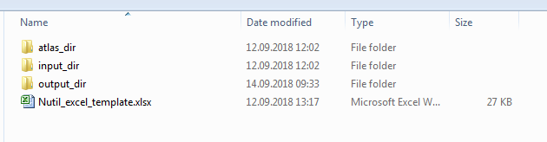

1. Save a copy of the Excel template, and populate the purple cells in the ***Quantifier*** sheet with the desired parameters. List the unique IDs (e.g. s0001) for each section for analysis in the *input list*.

NOTE: See the green fields and pop-up boxes for further instruction.

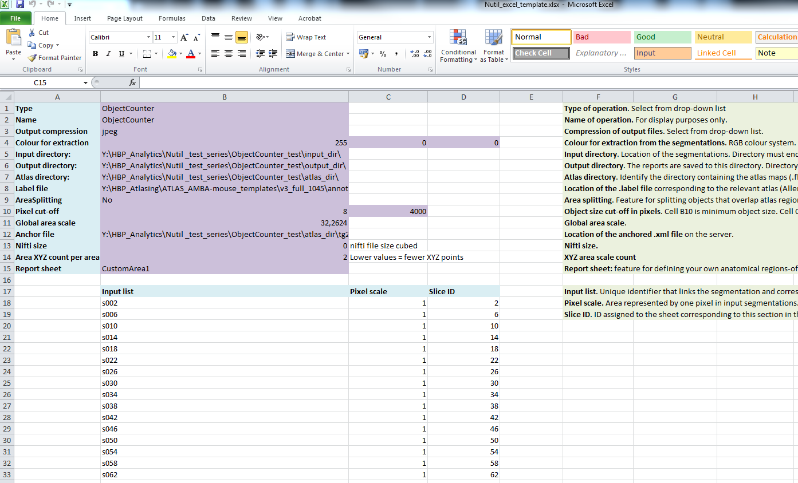

|  |
| --- |
| 1. Specify custom brain regions (**OPTIONAL**)   The *E*xcel template contains a sheet titled “CustomArea1” for defining your own custom regions and for assigning colours to the objects that fall within these regions (the colours are for display purposes only and apply to the image and coordinate output).  ***Quantifier*** produces reports organised based on the regions included in the reference atlas. This feature allows you to define your own regions of interest (compilations of reference atlas region IDs) to produce an additional custom report.    In **Row 1**, assign names to your custom regions (for example: hippocampus).  In **Row 2**, assign each region a colour. Do this by typing a RGB colour code in the following format: col: 255,0,0 (for red). The colour will be assigned to the objects located in the custom region in the image and coordinate output.  In **Row 3**, enter the name of the colour (for your information only).  In **Row 4**, define the region by listing the relevant reference atlas IDs.  For mouse, see the **ABAHier2015.xlsx** file for an overview of regions and IDs  For rat, the atlas region IDs can be found in the rat .label file  (both part of the Nutil package) |

1. Start *Nutil* by double-clicking on the "Nutil.cmd" file in the *Nutil* directory. You are presented with a simple screen:



1. Click the “Load XLSX”-button and navigate to the populated Excel template.
2. Once this file is loaded, select ***Quantifier*** from the dropdown box. Nutil automatically detects the number of available processors (8 in the example above). Choose a number below this value.
3. Press "Start" and wait until the batch process is complete. The output files are automatically saved to the output directoryspecified in the *Nutil* excel template.

**How to interpret the *Quantifier* output**

**OUTPUT FILES**

1. **Image .png**

These are the segmentations superimposed on the atlas maps. The object colours correspond to the anatomical regions that are defined by the user in the *CustomArea1* sheet. If custom areas and colours are not specified, or object falls outside of the specified areas, the objects are shown in red by default.

1. **Report.xlsx**

This is a summary report for the anatomical regions defined in *CustomAreas1*.

NOTE: This report is blank if no custom areas are specified.

1. **Report_slices.xlsx**

The first sheet of this report is a summary of all the objects in the whole series. Subsequent sheets give a breakdown of the objects per brain section (s002, etc).

In each sheet, the first two rows summate the results for the whole sheet (sheet 1 is for the whole series, sheet 2 is for slice 2, etc).

1. **Report_slices_summary.xlsx**

The *Report_slices_summary.xlsx* lists the results per section for the custom brain regions defined in *CustomArea1.*

NOTE: This report is blank if no custom areas are specified.

1. **Report_combined.xlsx**

Sheet 2 of the *Report_combined.xlsx* lists every anatomical region in the reference atlas with the number of objects found per region for the whole series (all slices combined).

1. **3D_combined.json**

This file contains the point cloud and can be visualised with the MeshView atlas viewer, which is available at [www.nitrc.org/projects/meshview](https://www.nitrc.org/projects/meshview) via the MediaWiki link.

**INTERPRETATION**

In each report.xlsx, the results can be interpreted as follows:

|  |  |
| --- | --- |
| **Region pixels** | Number of pixels that represent the anatomical region. |
| **Region area** | Area representing this anatomical region  *The unit is dependent on the pixel scale value that was entered in the excel template (the pixel scale defines the area represented by one pixel in the segmentations, e.g. 5 μm2 per pixel. The area is a summation of the pixel scale and the no. of pixels).* |
| **Object count** | The number of objects located in this anatomical region in the whole series.  *Note that objects that are larger than the maximum object size defined in the Quantifier template are divided into objects of the maximum size or less (a maximum size of 4000 pixels is recommended for smooth processing). If the segmentations contain objects that are larger than the defined maximum, only the object areas should be used (the counts are not accurate in this case).* |
| **Object pixels** | Number of pixels that represent labelling in this anatomical region. |
| **Object area** | Area representing labelling in this anatomical region in the whole series.  *The area is calculated by multiplying the object pixels by the global area scale and pixel scale defined in the Quantifier template.* |
| **Pixel area ratio** | Ratio of “number of pixels that represent labelling” to “number of pixels that represent the whole region”. |
| **Object area ratio** | Ratio of “labelling area” to “total area” (load). |

**Technical information**

The goal of Neuroscience Image Processing and Analysis utilities (*Nutil*) is to combine all labour-intensive pipeline operations in a fast and efficient piece of software that requires little understanding of programming.

### Development platform:

*Nutil* is written as a stand-alone windows 64-bit application written in Qt C++, which enables the full usage of both memory and processor cores. *Nutil* can be downloaded and compiled from the [github page](https://github.com/leuat/nutil). When performing batch processes, *Nutil* will utilise all cores available on the system.

The external libraries that are used in *Nutil* are:

* Libtiff for fast and efficient TIFF file handling (<http://www.libtiff.org/>)
* LibXLNT for excel file IO (<https://github.com/tfussell/xlnt/>)

### TiffCreator

### TiffCreator produces tiled TIFF files from JPEG or PNG images, and employs the support of multiple CPUs for efficient, parallelised operations.

### Transform

The image batch transform (*Transform*) enables rotations, scaling and thumbnail compilation of large tiff files (currently up to 4GB).

***Quantifier***

*Quantifier* identifies individual binary objects in a .png file, while matching these to output from *QuickNII*. The method first finds and sorts areas by using a standard pixel filler routine. Afterwards, a random area pixel is chosen as the look-up in the binary QuickNII label slice for this particular image. When all areas have been assigned a label ID, multiple selections of pre-defined area IDs are assembled (ID list from the excel input file), and finally output reports are assembled and written to disk (in xlsl format). In addition, original ilastik .png files with colour/ID coding added to underlying atlas slice data are assembled and saved to the output directory.